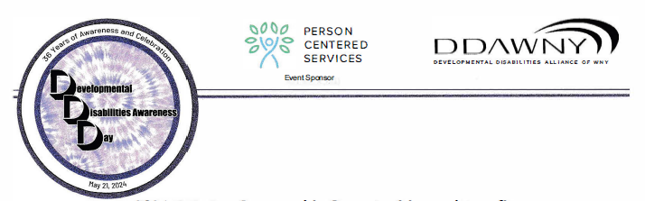

DD DAY POP-UP ART GALLERY

Dear fellow Artists,

As you are aware DD Day is just right around the corner. This year we are thrilled to include a new feature to our DD Day event, which is being held May 21st, 2024 at The Conference & Event Center, Niagara Falls, N.Y. Throughout the convention center we will be promoting and hosting POP-UP GALLERIES for everyone’s enjoyment. We are encouraging all Art Programs in WNY to come and share the works of their talented artists who attend their studios. Each Art Program will be assigned a specific area where your artwork can be displayed and shared with the conference attendees. We are looking forward to this year’s POP-UP Art Gallery being one of the best collective shows to date. We are very excited to add this as one of our featured activities.

In addition, if you know an artist from your studio that would like to be part of this POP-UP gallery experience and share your space, please encourage them to come and demonstrate their talents, we would love to have them be part of this day.

If you are interested in being part of this year’s POP-UP Gallery, please fill out and submit the attached form. Please take note, we will provide a 6 ft table if requested although you are responsible for bringing your own floor or tabletops easels, promotion materials for your programs and or any other items you feel would highlight the artists. All artwork, easels and any materials will need to be removed by the end of the conference. If you have any questions, please feel free to contact Amy Holdnack at amy.holdnack@aspirewny.org or call 716-512-6787. Please see the attached form to register for the POP -UP Gallery, and please remember EVERYONE will still need to register to attend the conference @ www.ddday.org Thank you.

POP-UP GALLERY REGISTRATION

- Agency -

- Contact Person -

- Contact Phone -

- Contact email -

- # of Artworks on display -

- Table - YES or NO

- Artist Demo – YES or NO

Once your registration form is received you will be sent an email confirmation with further details. 2 weeks before the event, you will be sent an email with your POP-UP GALLERY location.

Please send in all registration forms no later than Friday April 26th to:

Amy.holdnack@aspirewny.org

Fax 716-512-6789

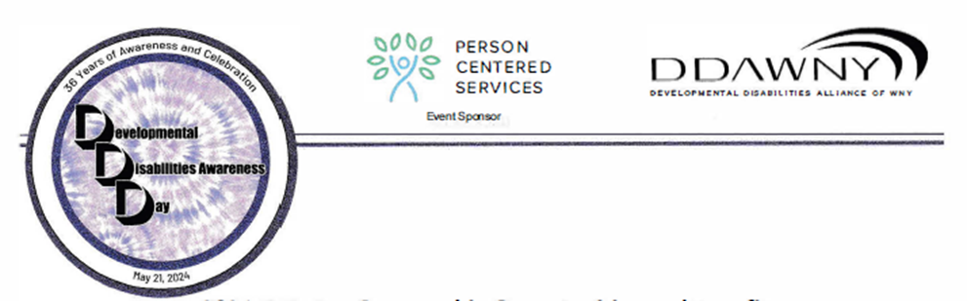
2024 DD Day Logo Contest
Artwork is now being accepted for the 2024 Developmental Disabilities Awareness Day Logo Contest. Artwork may be submitted by any individual with a developmental disability. The winning design will be used as the DD Day event logo, and may be used on souvenir tee shirts, day of program books, publications, etc.….

GRAND PRIZE: $100

REQUIREMENTS: All artworks MUST be an original drawing. Black and white OR up to four colors will be accepted. The design should be done on white or light-colored paper. Entries should be no larger than 8.5” X 11. Please do not submit any framed or canvas artwork. Your original design can be a symbol of the conference experience, an abstract concept or something that you find interesting. ONCE AGAIN, WE WILL BE ACCEPTING ORIGINAL DIGITAL ARTWORK. Digital artworks will follow the same requirement as listed above, send to amy.holdnack@aspirewny.org

The winner will be notified in April that their artwork was chosen as the winning design. The winning artist will be invited to attend the DDDay Award Luncheon as a guest on Tuesday, May 21st 2024. The winner will also be recognized during the event where they will receive their grand prize of $100 along with an award certificate. The winning design will be displayed throughout the DDDay Conference.

IMPORTANT NOTE: All entries MUST have the artist’s name, agency, address, and contact person’s name, phone number, and e-mail address on the back of each piece of artwork entered. Entries will not be returned and will become property of the planning committee. Entering artwork in this contest gives the planning committee CONSENT to use the artwork and the artist’s name for publications, display, publicity, or any general use.

PLEASE DUPLICATE THIS FLYER AND DISTRIBUTE TO ALL INTERESTED PARTIES.

Please bring or mail all artwork entries to:

Amy Holdnack
Aspire of WNY
7 Community Drive
Cheektowaga, NY 14225
Amy.holdnack@aspirewny.org

DEADLINE FOR SUBMISSION: March 29th, 2024. Thank you.

