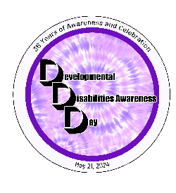
Sponsor Opportunities- All logo must be sent to devdisday@gmail.com-4/5/24
 | Event Sponsor | Scholarship | Event Program Book | Keynote | Luncheon | Healthy You | T-Shirt | Reception | Parking | Breakout Sessions
 | $5,000 | $2,500 | $2,500 | $2,500 | $2,500 | $2,500 | $1,000 | $1,000 | $1,000 | $1,000
Total sponsors | 1 | 4 | 1 | 1 | 4 | 2 | 1 | 2 | 1 | 2
Complementary Lunches | 8 lunches at reserved table | 4 | 4 | 4 | 4 | 4
Full Page Add in Program
½ Page Ad in Program
Recognition on Social Media
Name Displayed | Name/logo on all media.  Front of Registration Brochure  Inside Cover of Event Program Book.  Name at front entrance | Recognition in the Event Program Book | Recognition in the Event Program Book | Banner in Keynote area | Banner in Luncheon area | Banner in Healthy You area | Sleeve of shirts | Banner in Reception area | Banner in Parking Area  PLUS one free parking space | Displayed on Room Screen
Vendor Fair (8’ table)
2 Registrations for working vendor table LUNCH NOT INCLUDED

Vendor Opportunities- All logo must be sent to devdisday@gmail.com-4/5/24
 | Platinum | Gold | Silver | Profit Businesses | Non-Profit Businesses
Sponsorship | $750 | $500 | $250 | $150 | $100
Listed in Event Program Book
Listed on DD Day website
Vendor Fair (8’ table)
2 Registrations for working vendor table LUNCH NOT INCLUDED

